Title: Autonomous Trash collection and disposal robot simulated in ROS/Gazebo Environment.
Name: Dipesh Budhathoki

Abstract:
The concept of smart homes is gradually becoming a reality and the need of service robots for domestic purposes is increasing with it. The goal of this project is to create an autonomous robot that can collect trash from a certain area of a household and place it in the dumpster. The robot then makes its way back to the starting point and does its chores as scheduled. One of the schedules cycles is demonstrated in this project. To successfully navigate, avoid obstacles, and accomplish its goal, the robot used a hybrid control system that processed the sensor data from laser, IMU, and odometry. Also in this project, the contrast is shown in the navigation of the robot with and without the path planning algorithm. This article details the construction of such a robot within the ROS/Gazebo simulation environment.

Introduction:
Automation of household tasks improves sanitation and efficiency, especially about waste management. The concept presents a robotic system to handle the chore of moving water from an indoor area to a disposal location on its own. This project contributes to the rapidly expanding field of home automation systems and falls under the umbrella of improving residential living through robotics.
The ROS-Gazebo-simulated robot combines a few sensors for obstacle avoidance and navigation. The system has the potential to be used in the real world because it is made to be reliable, effective, and able ot self-navigate in a changing environment. This project develops the fundamentals ideas of path planning and robotics to create an autonomous robot that can pick up trash by navigating a residential area. Finding the best route from the starting point to a goal while avoiding obstacles is known as path planning, and it is an essential component of robotics. The robot must perform this difficult task in real time, making judgements based on pre-programmed algorithms and sensor inputs. The procedure comprises a detailed examination of the surrounding conditions, the forecasting of dynamic shifts, and the development of an adaptable navigation plan.
To navigate the robot, our method combines reactive strategies and deterministic algorithms. The deterministic part entails placing waypoints along a predefined track to direct the robot toward the dumpster and then the trash pickup station. When the robot comes across unanticipated barriers, the reactive component kicks in, utilizing sensor data to dynamically modify its path. This approach works best when waypoints specify the overall course and local modification are done in response to urgent environmental inputs. But in our project, we have intensely utilized the reactive strategies and only fixed the goal point and the starting point. We tackle the more general problem of robotics autonomy—that is, a machine’s capacity to carry out activities without the assistance of a human – by creating this robot. For a robot to be considered autonomous, it must be able to move around, make decisions. Adapt to new circumstances and draw lessons from its past. These skills are essential in a home environment because it is less controlled and more variable than in an industrial setting.
The methods for the robot’s path planning and navigation, the incorporation of sensors for environmental interaction, and the specifics of the implementation that lead to the task of collecting rubbish autonomously will be covered in the following sections.
Approach:
The robots control system is built upon a PID like control approach with sensor data combined with potential field path planning algorithms. The attractive potential field guides the robot towards the goal while the repulsive field prevents the robot from colliding with obstacles. The hybrid control employed in the robot is described briefly below:
- Attractive force: The robot is attracted towards the waypoints using a force that is proportional to the distance from the target, transitioning to a conical potential beyond a threshold distance. A robot performs has better performance if we define the waypoints throughout the path but for this project, we wanted to exploit the dependency on different sensors to find its optimal path in real time. Thus, only the starting point and the goal point was defined.

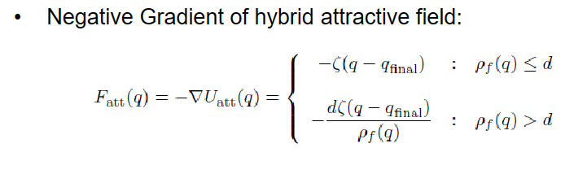
Figure 1: Equation for attractive field.
- Repulsive Force: A repulsive force is proportional to the inverse square of the distance from the nearest obstacle and becomes active within a certain range. For this project, we have focused on the dynamic detection of the sensor rather than defining the obstacle.
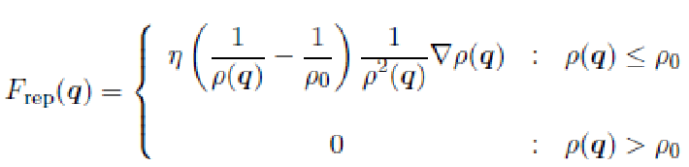
Figure 2: Equation for the repulsive force.
- Laser Sensor: It is used for real-time obstacle detection, and it provides the distance measurement necessary for the repulsive force calculation. The laser sensor we used in the ROS/Gazebo environment is a Hokoyu sensor.
- IMU: It provides orientation data to maintain the robots heading and helps in trajectory correction.
- Odometry: It delivers accurate positional information for navigation towards goal and ensures the robot returns to its starting position.
For this project, our main goal was to drive our robot from a predefined point near the household

